Write a map reduce program to use Sequence file as input and save the output in key value output format.

**Driver class:**

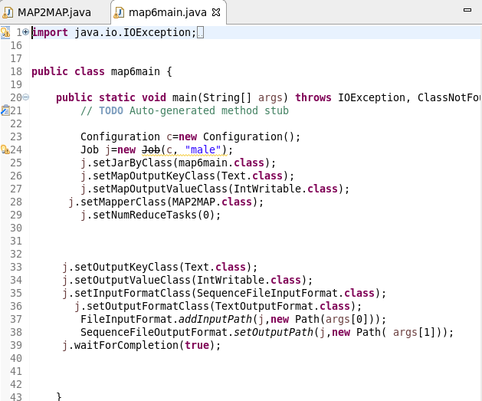

**Mapper class:**

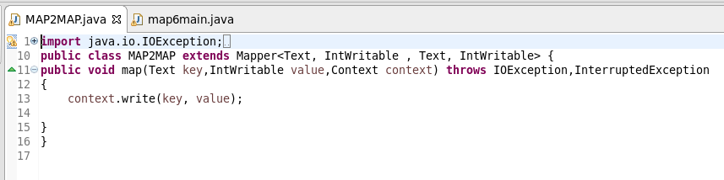

**Sequence file as input:**



**Output:**

